Designing for users
This article describes some design dilemmas and discusses some approaches to resolving them.
The project described is WXT (Web and Xml Tool). WXT is an engine that builds websites and related documents like extracts for PDF-books. The job that WXT does is described by a XML-script. So the only thing the WXT-engine can do is to read a script and process it. WXT is implemented in Java and the WXT-engine is a jar-file.
WXT is built for the purpose of maintain learning material and it is built by the authors who are both experienced teachers in Computer Science. That means that:
- We know what we want the tool to do.
- We know all the technologies involved, CSS, XML, XHML, XPath, XSLT, Processing Instructions, AJAX, Javascript etc.
Based on this we have produced an engine that works just fine, is efficient and reliable in our daily work and makes it possible to maintain material that we otherwise would not have the resources to keep up to date.
So the question is then: How should we explain this brilliant tool to the rest of the world, or at least some of it. We have made a rather detailed description, a user manual and a number of examples, but it is fairly clear that we do not reach beyond the group of people with more or less the same background as ourselves. Even with this narrow audience we have a non-trivial job to explain that the investment of a few hours trial and fail pays off.
An argument is of course that we have designed this tool the wrong way. We should have started out with a reasonably clear audience in mind and designed the tool for and together with representatives for this audience. This is a strong argument and we would on a general basis agree that this is the way to do it. On the other hand it is fairly obvious that by using ourselves as audience in a highly iterative design process we have been able to identify and solve problems in a depth that we may otherwise have missed.
Anyhow we are stuck with a problem: We have a fairly general tool and we want to “sell” it.
There are two key questions:
- How do we explain the script, with addressing strategies, templates etc?
- How do we explain how the authors should prepare their material as XML or plain text so WXT can identity fragments, move them and even transform them?

Technical preparations
The basic way to invoke the WXT-engine is from the command line:
java -jar wxt2.jar C:\mysite\script.xml

We can in addition supply some options and we can build only some of the modules in the script:
java -jar wxt2.jar C:\mysite\script.xml -m p1,px

Designing for a GUI
WXT is from the beginning designed with the plan to add a GUI. This design involves a clear definition of how the classes within WXT cooperate and how we access this structure from a GUI.
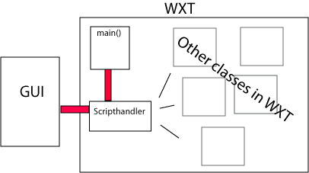
All access to the WXT-engine is via a Scripthandler object. This objects controls all building and reporting. The main() function and an external GUI communicates with the Scripthandler through similar interfaces.

Implementing a GUI
There are many ways to realize a GUI given the structure explained above. We have chosen to go for a solution where we can have different GUI’s working against the same WXT-engine. We can start the GUI which locates the WXT-engine and set up a contract. A contract consists of an interface to the Scripthandler. The functions describing the contract are:
Class Scripthandler
Scripthandler (…) constructor
BuildModules(…)
getModuleDescription(…)
getModuleLocations(…)
getModuleAddress(…)
getReport()
getVersion()
The Java code for setting up a contract is described in appendix A.
Thus we are in a position to establish a Scripthandler and communicate with it. We can ask WXT to build modules and we can request a report describing possible errors and warnings.
The basic GUI is made as a utility that serves mainly as a tool for the original user group, us. All though it is reasonable efficient and gives great support in administrating scripts, it adds little to the general understanding of the functionality of WXT, and it adds no support for preparation material. A snapshot may look like this:
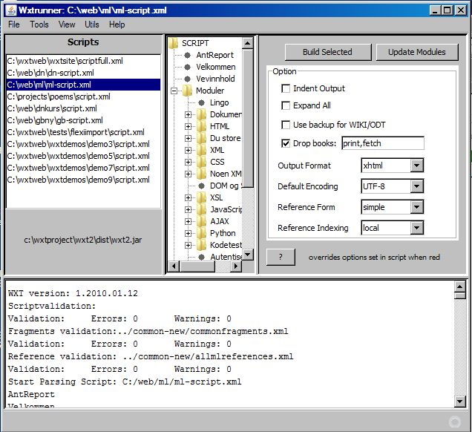

Redesign
So the question is now: Given the WXT-engine and the possibilities for coupling any GUI to this engine, can we make a redesign for another user group and/or a more specialized application type?
Is the engine general enough? Should the GUI focus the building process as described above, should it focus be on the author’s tools or should we focus on site structure?

Roles
A crucial question of course is which roles can we indentify as user of WXT. There are at least three, in addition to the reader which we should be faced with well formed flexible web pages.
- Author. WXT can produce material supplied from any number of authors which make their contribution available on the net, as an URL. The material the authors produce must have a form and must be marked so WXT can identify and collect the actual fragments. This means that an author must know how to prepare material.
- Editor. An editor is responsible for maintenance of the material. In principle it is the editor who runs WXT. An editor must control the file structure, versioning and must be responsible for changes in templates, layout and styling. An editor must probably understand the basic role of the script and should detect and react to malformed material, based on reporting from the WXT-engine.
- System administrator. A system administrator must know the ins and outs of the script and must resolve problems connected to the limitations of WXT.
We, the authors, combine all these roles, and are in some perspective involved in a never ending development process. It is reasonable to assume that the combination of the two first roles will be a common case.

Terminology and metaphors
As always the use of words is important. Some basic concepts in WXT are:
- Module. A module is the basic building brick in WXT. Normally a module is synonymous with a web page. A module is in general an XML-file based on a template and any number of content files.
- Template. A template is an XML file which is marked to receive identifiable fragments from content files.
- Content. Content in WXT may be files of type XML (and thus XHTML), HTML, TEXT and Open Office text documents. In addition content may be fetched from a database. All sources for content is identified by an URL, local or remote.
- Fragment. A fragment is a piece of a content file. Fragments are identified by XPath or by means of extracting flat text.
- Style. WXT relies on the use of stylesheets, CSS.
- Transformation. WXT allow transformations of content and of final modules. A transformation is an XSL -Transformation.
- Script. The script is a job description for WXT formulated as XML. To run WXT means parsing and interpreting an XML-file.

Functionality
The question is now which role should have focus when we make the GUI and which concepts must the user understand and which functions should the GUI support.

The Author.
The author’s basic need is to produce well formed material as efficient and safe as possible. There are many author roles and tasks.
The most common situation is probably where the author’s contribution is an XML or HTML page. Well formed will in this context normally mean two things. Firstly, the material should be well formed XML or HTML. Secondly, the material should be tagged so WXT know what to use.
A similar situation is when the author contributes an Open Office text document. In this case the marking will be a little different.
We can also see the author as a programmer that contributes with code fragments.
The author may also be one who maintains a database.
One key question is whether a GUI should incorporate tools that are handy for the author. This will in general mean editors for XML, XHTML , CSS with support for the specialized Processing Instructions that is involved in WXT’s mechanisms for performing its job.
One way to approach this is to build an application based on a general IDE like NetBeans (“The only IDE you need”). The problem with this approach is that, even if we reduce the functionality of the IDE, the result will probably be so complicated that we do not necessary reach out to a wide user group.
Another way to approach this is to supply the editors as part of the GUI. This is of course possible but it is hard to do good enough compared to highly specialized tools that the author may be used to, and it involves a lot of code.
A third approach is to make a GUI without content editors, and invoke the users’ favorite editors from the GUI. This seems to be a reasonable solution, if we want to make a tool for authors.

The Editor
Basically the editor should be able to do the same things as the author, with the exception of programming and database maintenance. . It is essential that the Editor has control over templates and stylesheets. In addition the editor must control the structure of the material, the file system and the running of WXT
Again a general IDE, like Netbeans, is a possible solution. In addition to the editing possibilities, NetBeans will support easy access to the file system, scripting tools and we could easily incorporate start of WXT with a button in the IDE.

The System Administrator
We will not follow this thread in depth. We conclude with an assumption that the system administrator must be familiar with the WXT-documentation and topics like operative system, volume mapping, VPN, FTP etc. The system administrator will probably be reasonably happy with a GUI as described above.

The Targeted User and the Tasks
Based on this analysis we conclude the user of our GUI is the editor. We may attempt to set up a temporary specification of demands.
- Easy access to editors for the actual file types
- Manipulate some options influencing the performance of WXT
- Run the WXT-engine with a button click
- Read report from the WXT-job
- Manipulate the structure of the material
- Inspect the resulting modules and other material
What must an editor know to do these tasks efficiently? What does have to know about WXT and what does he have to know about the technologies involved? Let us look at the latter question first. It is probably three basic issues:
- XML. It is hard to see that an editor may do the job without a basic understanding of XML (XHTML).
- CSS. This is the key to all layout and styling. Probably some basic, default style sheets could cover up for lack of a deeper understanding
- WEB publishing. This is a an issue that involves some knowledge of the most common browsers and how they react to headers and file extensions. Again some default solutions may be useful.
When it comes to WXT the editor should have a basic understanding of how material is collected and moved and how this can be controlled by Processing Instructions. Given some basic knowledge of XML, this knowledge should be achieved via a reasonable documentation.

The Domain
Given that the user is the Editor, the next question is: Editor of what? Should we attempt to make the GUI general, adaptable or should we make a set of specialized GUIs ?
This is a question of metaphors and abstraction. The key concepts listed above (module, template etc.) would indicate a general, abstract approach.
We may however think different. Assume that we want to design a GUI for web site (and book) on recipes. It would be useful and simplify things if we could work with concepts like: recipe, ingredients, preparing, serving, illustration. We could use these terms in the GUI and we could easily convey those concepts to the authors and we have simplified the communication between the editor and the authors.
The crucial question is: Can we combine the two approaches?

An approach

Script or No Script
We try out an approach where the script is not an issue that the user should care about. The script is a consequence of the selections and actions the user perform in the GUI. If we do this we will probably have to focus on specialized applications where we don’t use the full potential of the WXT-engine.
If we follow this thread we will have to have a GUI that administrates modules and content, and are controlled by a limited number of options.

Appendices

Appendix A
Setting up a contract between the GUI and the WXT-engine:
The functions describing the contract are:
/** The wxt2.Scripthandler class*/
Class m_Scripthandler=null;
/** The constructor for wxt.Scripthandler*/
Constructor m_Constructor=null;
/** The method for wxte.Scripthandler.BuildModules()*/
Method m_BuildModules=null;
/** The method for updating modules with changed content*/
Method m_UpdateModules=null;
/** The method for wxt.Scripthandler.GetReport()*/
Method m_GetReport=null;
/** The method for wxt.Scripthandler.getModuleDescription()*/
Method m_getModuleDescription=null;
/** The method for wxt.Scripthandler.getModuleLocations()*/
Method m_getModuleLocations=null;
/** The method for wxt.Scripthandler.m_getModuleAddress()*/
Method m_getModuleAddress=null;
/** The method for accessing the current wxt version */
Method m_getCurWxtVersion=null;
And we set it up like this:
URL urls[]={};
JarFileLoader jfl=new JarFileLoader(urls);
jfl.addFile(wxt2path);
m_Scripthandler=jfl.loadClass("wxt2.Scripthandler");
m_Constructor=m_Scripthandler.getDeclaredConstructor(HashMap.class);
m_Constructor.setAccessible(true);
m_BuildModules=m_Scripthandler.getMethod("buildModules", HashMap.class);
m_UpdateModules=m_Scripthandler.getMethod("updateModules", HashMap.class);
m_GetReport=m_Scripthandler.getMethod("getReport", (Class[])null);
m_getModuleDescription=m_Scripthandler.getMethod("getModuleDescription", String.class);
m_getModuleLocations=m_Scripthandler.getMethod("getModuleLocations", (Class[])null);
m_getModuleAddress=m_Scripthandler.getMethod("getModuleAddress", String.class);
m_getCurWxtVersion=m_Scripthandler.getMethod("getVersion", (Class[])null);

